**AI BASED DISCOURSE FOR BANKING INDUSTRY**

**Team ID:** PNT2022TMID27784

**PREREQUISITES:**

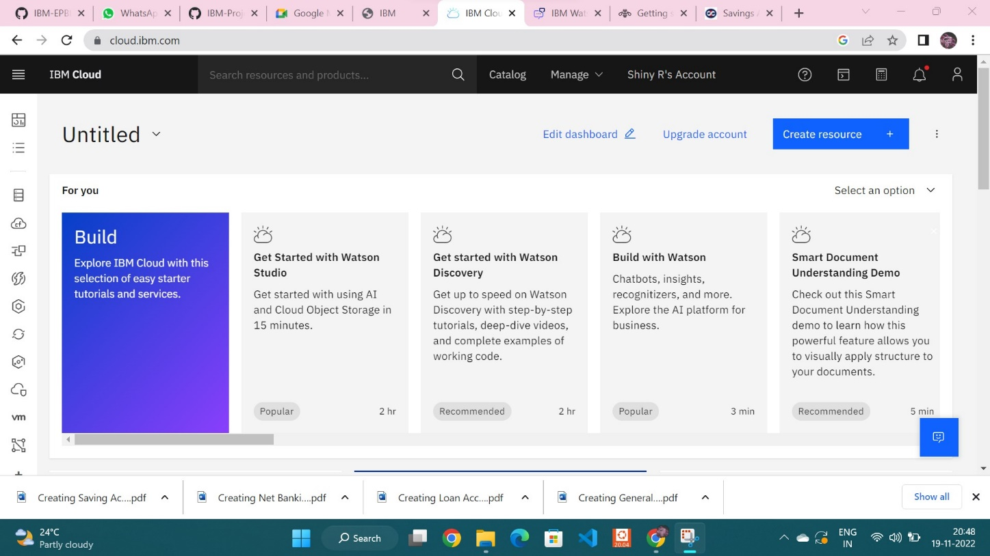

Successfully registered and logged on into IBM Cloud Account.